India is a vast and beautiful country. There are numerous reasons why you should choose India as your next travel destination. Be sure to have your Travel Brochure handy before making any decisions.
Select one city of your choice and calculate the cost of visiting that city.
You will only need to calculate the cost of one person traveling to the city.
If time permits, your team can calculate the cost for your entire team traveling.
The Indian rupee (sign: ₹; code: INR), is the official currency of the Republic of India. The prices below are estimates for one person traveling.
Cities in India | Major Attraction | Food/Cuisine | Things to do:  Art & Culture
AGRA | ₹2,000 | ₹400 | ₹90
DELHI | ₹3,000 | ₹200 | ₹80
BENGALURU | ₹2,000 | ₹300 | ₹70

Which city did your team decide to visit? ____________________________
Why did your team decide to visit this location? ____________________________________________________________________________________________________________________________________________

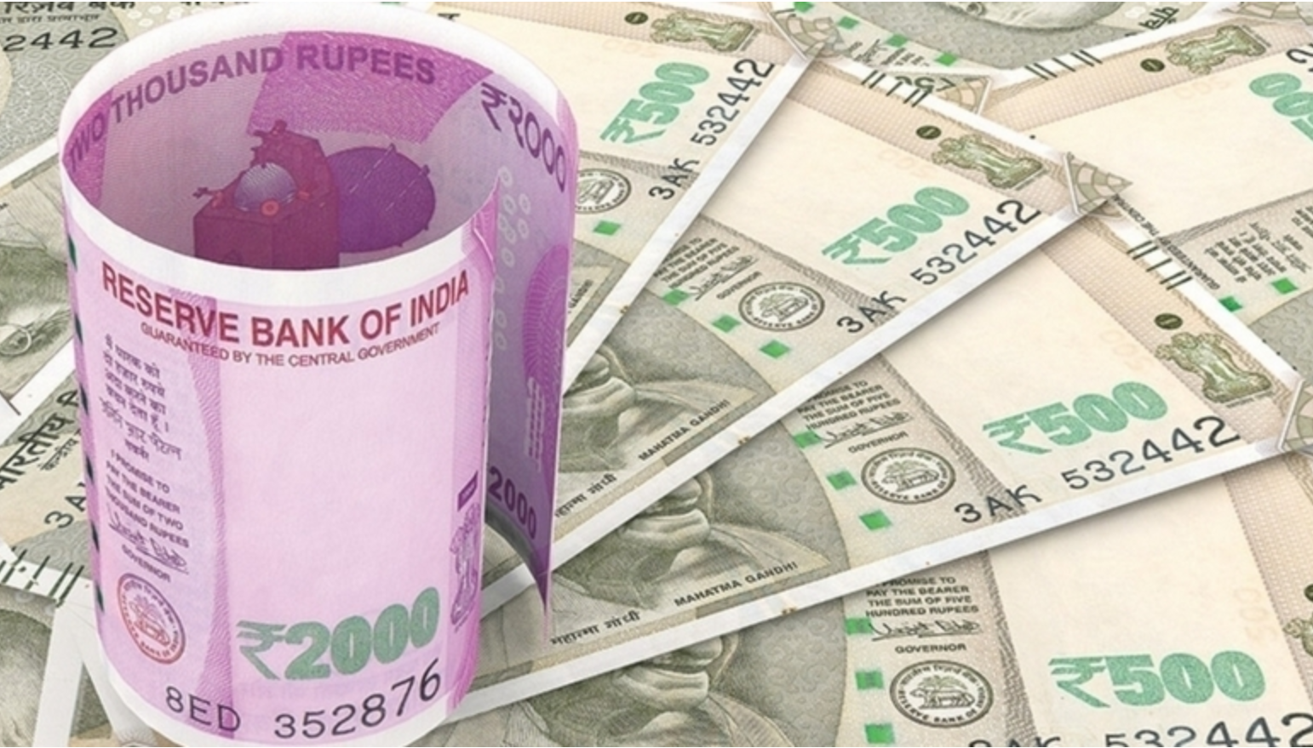
How much would it cost for one person on your team to visit?
(add the prices together - show your work)

Major Attraction __________
Food Cuisine __________
Things to do __________
TOTAL COST: ______________

Decompose the total cost:
e.g., 2,763 equals 2 thousands, 7 hundreds, 6 tens, and 3 ones
________________________________________________________________________________________________________________________________________________________________________________________________________________________

