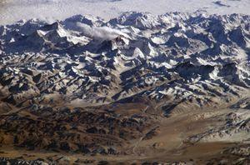

FACTS ABOUT THE HIMALAYAS

The Himalayas are a mountain range in South Asia, the highest in the world.

The word "Himalaya" means House of Snow. The Himalayas are so high that they kept the Indian and Chinese people separate from each other most of the time. In fact, India is a peninsula that is cut off from the rest of Asia by the mountains. India is often called a sub-continent because it is larger and more isolated than other peninsulas.
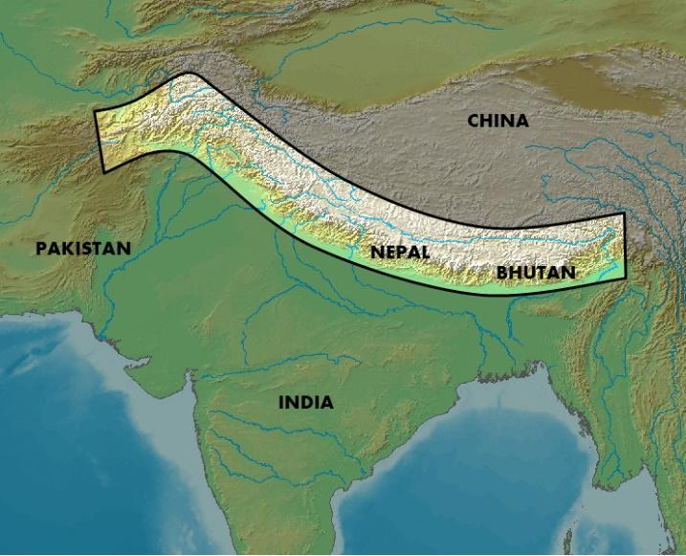

The Himalayas are very popular for tourists because it has a lot of wildlife. Common animals, which are seen mostly in the different parts of the Himalayas, are snow leopards, blue sheep, musk deer, tigers, elephants, wild boar, and crocodiles. Even endangered species of animals and plants are also found there.
In the north part of the Himalayas where the temperature falls below freezing point, animals cannot survive well.
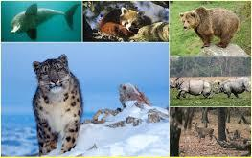
However, those who adapted can survive. During the cold winter's most of the animals migrate to the lower regions of the Himalayas while others like the brown bear hibernate instead. The Yak is mostly seen in the cold desert. They are like wild ox and they are the largest animals in this region.

FACTS ABOUT THE ANDAMAN and NICOBAR ISLANDS
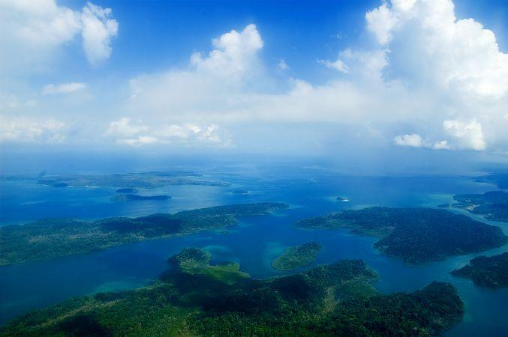

The Andaman and Nicobar Islands is a union territory of India. The name is often shortened to A & N Islands, or ANI. The islands are in the Indian Ocean, in the southern part of the Bay of Bengal. It is made of two island groups - the Andaman Islands and the Nicobar Islands - separating the Andaman Sea to the east, from the Indian Ocean.

The Andaman and Nicobar Islands have a tropical rainforest canopy. This tropical rain forest is rich with a diversity of animal life. About 50 varieties of forest mammals are found in the Andaman and Nicobar Islands. Rodents are the largest group with 26 species, followed by 14 species of bats.
The State Animal of Andaman is the dugong, also known as the sea cow, which can be found in Little Andaman.
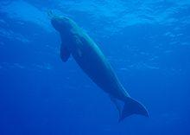

About 270 species of birds are found in the territory. The islands' many caves are nesting grounds for the edible-nest swiftlet, whose nests are prized in China for bird's nest soup.
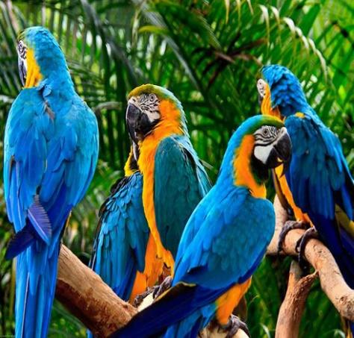
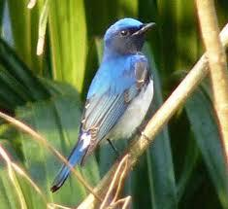

The territory is home to about 225 species of butterflies and moths. Mount Harriet National Park is one of the richest areas of butterfly and moth diversity on these islands.

The islands are well known for prized shellfish. Many villagers produce a range of decorative shell items. Giant clams, green mussels and oysters can be eaten. The shells of scallops and clams are burnt in high-heated ovens to produce lime powder.
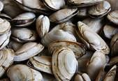
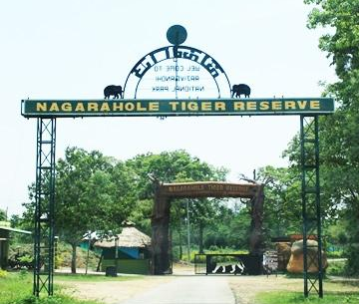

FACTS OF NAGARHOLE NATIONAL PARK
Nagarhole National Park is one of the best places for wildlife travel in India.

'Nagara' means snake and 'hole' means river. It gets its name because of the river that looks like a slithering snake. It is also known as Rajiv Gandhi National Park and is one of the most popular parks in South India.
Nagarhole National Park is located between the borders of Mysore and Kodagu districts.
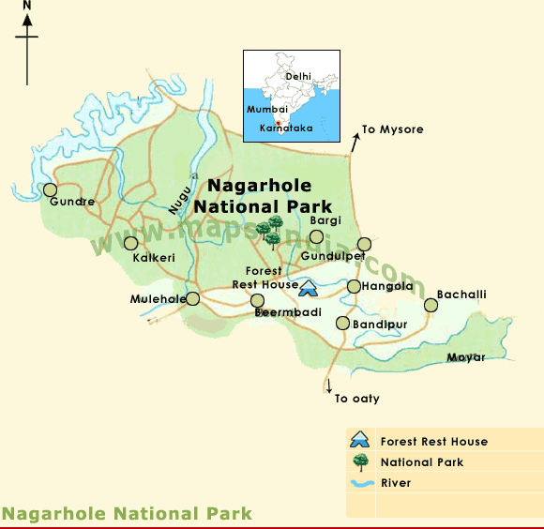

Nagarhole is a protected reserve and it is also one of the top tiger reserves in India.
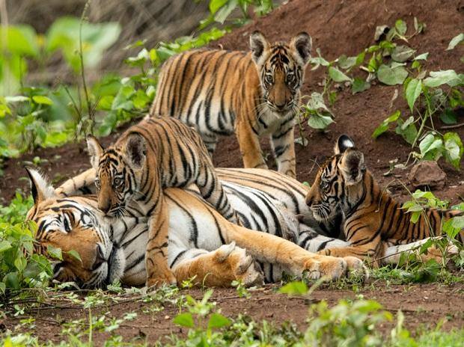
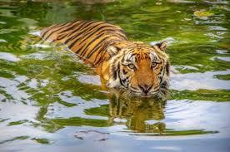

The park protects many animals of Karnataka. The important predators and carnivores in Nagarhole National Park are the Bengal tiger, Indian leopard, sloth bear and the striped hyena.

The herbivores are chital, sambar deer, barking deer, four-horned antelope, gaur, wild boar and Indian (Asian) elephant. Herds of elephants are a common sight on the banks of the river. Overall, one gets to see happy crowds of animals in their natural habitat!
The park also has a good number of golden jackals, grey mongoose, sloth bears, striped hyena, spotted deer, four-horned antelopes and wild boar.
