Engineering design is a three-part process.
- Defining a problem — in this case, making a bridge. This step includes establishing criteria (the bridge must span 6 inches and be 3 inches wide - math connection/have rulers available for students) and identifying constraints (building materials are limited to two pieces of paper - nothing else, no tape).
- Developing solutions — students creatively develop different bridge designs.
- Testing and improving designs — students test each design’s strength by stacking pennies on the bridge until it collapses. They carefully observe to identify failure points, then redesign their bridge to make it stronger.
  - Failing is an important part in the engineering process. Students learn from their attempts and redesign to make it stronger.

Ways to encourage your students:
- Appreciate students’ efforts no matter the results.
- Remind them that “failure” is a necessary part of the design process. Watching a bridge fail helps you find ways to make a better bridge.
- If the class needs more guidance, watch the Sprouts Team video. In this video, the Sprouts team experiments with bridges, watching them fail and making improvements from what we learn.
- If students have difficulty identifying how to improve a bridge, ask them to watch it collapse again and tell you exactly what happened, step-by-step. For example, “It started to flatten out and then it bent in the middle.” When they have identified what happened, ask if they have ideas about how to prevent that from happening. “What could stop it from bending there? Is there any way to support the middle or make it stronger?”
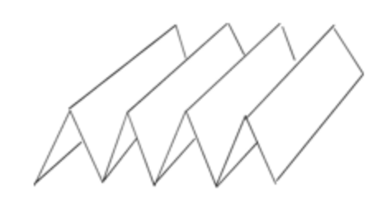
- Remind them that they can make paper stiffer by rolling it or folding it.

Choosing a winner?
After your students design their bridges, we suggest a class discussion where you talk about which bridge supported the most pennies and recognize the winning design for “strongest bridge.” You may also want to select winners for “most beautiful bridge” and “most creative use of paper.”

