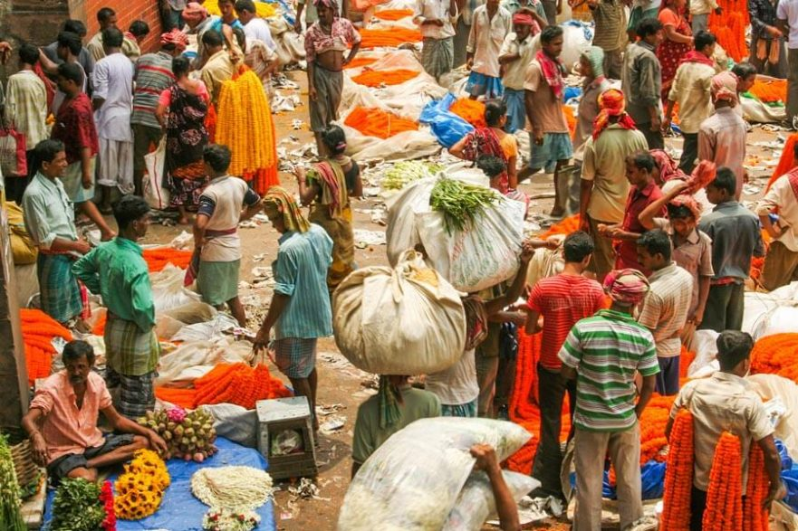

Overview

Students have just traveled from the United States to India. As they land and exit the plane, they will be surrounded by the sights, smells, and people of India. In this lesson, students will have the opportunity to explore India using their 5 senses, exploring the marketplace and other parts of India as a focus on the cultural traditions of India.

Education Standards
Social Studies
3.4(E) identify and compare the human characteristics of various regions
3.13(A) explain the significance of various ethnic and/or cultural celebrations in the local community and other communities
3.13(B) compare ethnic and/or cultural celebrations in the local community with other communities
3.16(B) identify the impact of scientific breakthroughs and new technology in computers, pasteurization, and medical vaccines on various communities

Materials Needed
For Station 1: The Sound of India
- A bongo or drum (can use an empty oatmeal can, if drum is not available)
- A guitar (can use a shoebox with rubber bands, if the guitar is not available)
For Station 2: The Smell of India
The following spices: Curry, Turmeric, Cumin, Ginger
For Station 3: The Taste of India
- Naan Bread (enough for each student to have a small taste)
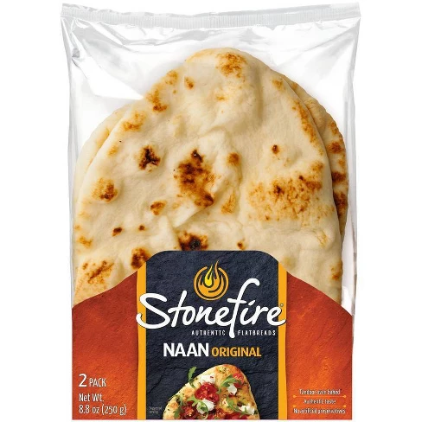
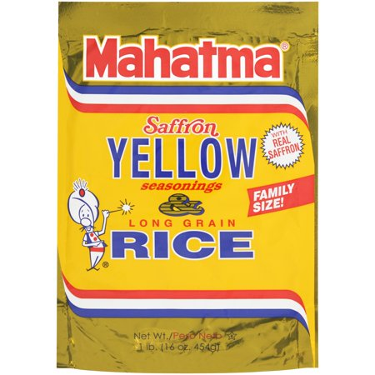
This bread can be found at your local HEB near the deli area
- Saffron Rice (can be found at HEB or Walmart)
- Recipe for Tandoori Chicken (recipe can be copied and sent home)
- 1 oz cups and spoons for tasting
For Station 4: The Sights of India
- A 360º Virtual Tour of India
https://youtu.be/xf_MlReoHLM
Students will need an iPad or Laptop to view this video
For Station 5: The Inventions of India
- Invention cards
- following items to explore: a ruler, buttons, chess pieces, and cotton
Every Station will need:
- The Heart of India Booklet (each student will have their own copy)
- File folder for each student to hold their response sheets throughout the segment (optional)

Vocabulary
Culture- a pattern of behavior shared by a society, or group of people. These things include food, language, clothing, tools, music, arts, customs, beliefs, and religion.
Tabla- a pair of small hand drums attached together, used in Indian music; one is slightly larger than the other and is played using pressure from the heel of the hand to vary the pitch.
Sitar- a large, long-necked Indian lute with movable frets, played with a wire pick.
Cuisine- a style or method of cooking, especially characteristic of a particular country, region, or establishment.
Marketplace- an open space where a market is or was formerly held in the town.

Student Objectives
- Students will gain an understanding and appreciation of cultural diversity by transitioning through hands-on stations.
- Students will use their 5 senses to explore the heart of India.
- Students will acquire authentic experiences of India as they learn about the culture.

Activity
- Set the Stage for the Students: Teacher will read the mission and purpose of the trip to India. Teacher will explain that before a team can go into an unknown country, they must get to know the culture and explore the vast regions, looking for necessities, such as food, clothing, and other resources.
- Teacher will explain to students that they will be transitioning through 5 stations to complete their Heart of India booklets. Booklets will be taken from station to station.
It is important to fill out as much information as they can, which will be used in the final lesson to report their research findings.
Each station will be 8 minutes (5 minutes to explore, 3 minutes to record responses in their Heart of India booklets ). Teacher will divide the class into 5 groups of 4-5 students each, prior to starting the lessons.
- Setting Up the Stations
Station 1: The Sound of India
Students will have the opportunity to play a drum (tabla) and guitar (sitar) to compare the sounds and design of each instrument. If the teacher cannot provide some sort of percussion or string instrument, then resort to an oatmeal can and a shoebox with rubber bands. Place instruments on the table with the sound and instrument cards.
Station 2: The Smell of India
Students will use their sense of smell to explore the following spices:
Curry, Turmeric, Cumin, Ginger. Students will use the spice cards to get information about each spice. Students will record their answers in their booklet. Place spices and spice cards on the table.
Station 3: The Taste of India
Students will taste Naan bread (common to India) and Indian Saffron Rice (can be prepared by the teacher the night before; the rice is instant and comes in a family size). Cut Naan bread into sample sizes and serve 2 tablespoons of rice into 1 ounce cups with a spoon. Teacher can decide if she wants to make the recipe for Tandoori chicken, or just have students view the recipe. Students will also get to take home a recipe of Tandoori Chicken to share with their families. Students can discuss which food item they like best.
**Please make sure you know your students’ food restrictions or food allergies.**
Station 4: The Sight of India
Students will take a virtual tour through India’s most profound cities by using their iPads. Students will navigate through the tour by manipulating the screen to see a 360º view of each area. If students are using an Ipad, make sure to have them move it around. If students have a laptop, make sure that they position the cursor to move the screen setting around. The link should be provided through a QR code. If iPads or laptops are not available, the teacher can set it up as a viewing station only and students can watch it on a screen.
Station 5: The Inventions of India
Students will learn about various inventions that were inspired and created in India. They will explore by matching the card to the item (ruler, buttons, chess pieces, and cotton) and reading about how the culture of India has played an important role with the inventions. Place items and cards onto the table and allow students to explore and work in their booklets.
As students get done, ask them to store their booklets in a file folder for further use.
Think, Pair, Share
Students will partner up with another student to discuss what their favorite station was. Ask students to share what they learned at that station.

Extension
Students can choose one of the inventions and create a better way to use it (an innovation). Students can draw, write and even use the item to show how they would make it better.

