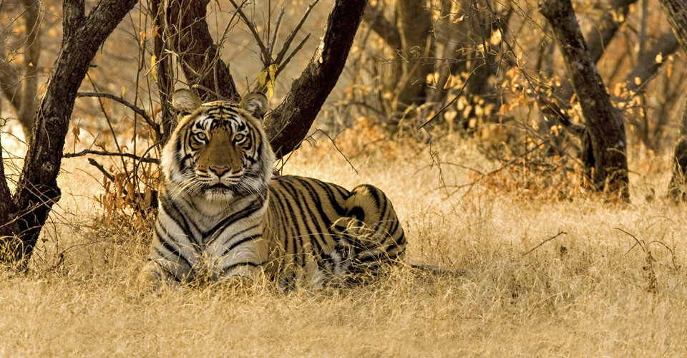

Overview
Students will travel to the rural areas of India to investigate how animals in India adapt to their surroundings. They will learn about various animals that live in 3 regions of India. They will come in close contact with the animals of these regions to discover their living conditions. Students will also analyze different scenarios of changes to an environment and will describe whether organisms can survive in that ecosystem.

Background Information
Environments have specific physical characteristics that provide food, water, air, and protection to populations and communities in an ecosystem. Changes to an environment can affect whether certain organisms can survive in that ecosystem.
Environmental changes such as floods, droughts, or fires will cause some organisms to perish or move while permitting other organisms to thrive. Animals are a main target for poachers and, due to commercialization, even the tribesmen (Jenu Kurubas) of the forests in India hunt animals for money. There is a dire need to take precautionary measures to protect the forests from natural calamities like forest fires, poaching of animals and cutting timber. Thus, the animals and even the trees, like sandalwood, are under threat. During this lesson, students will gain an understanding of how these changes can affect wildlife.

Education Standards
3.9(A) observe and describe the physical characteristics of environments and how they support populations and communities of plants and animals within an ecosystem
3.9(C) describe environmental changes, such as floods and droughts where some organisms thrive and others perish or move to new locations
3.10(A) explore how structures and functions of plants and animals allow them to survive in a particular environment

Materials Needed
- White cardstock
- 3 index cards
- 8 rocks the size of a half dollar
- Handful of cotton
- 3 small ziplock bags for storage
- 1 sheet of white construction paper
- 2 sheets of green construction paper
- 2 sheets of blue construction paper
- Pictures of animals - provided on a PDF document (copied on cardstock)
- Informational Sheet- Facts about 3 Ecosystems in India
- 3 shoe box lids

Vocabulary
ecosystem drought
thrive population
perish community
flood environmental changes

Student Objectives
Students will learn what animals need to survive in their environment.
Students will identify causes of environmental hazards, or changes, that can occur within an ecosystem.
Students will learn how wildlife in India adapt to these changes.
Students will explore various ecosystems and will be able to determine what animals would perish or thrive within that setting.

Activity
PRE-LESSON PREPARATION
The teacher will create 3 models of ecosystems (ahead of time) using a shoe box lid, and will follow the directions for each one. **If time permits, teachers can have students set up the models during the lesson. ** (see pictures of models)**
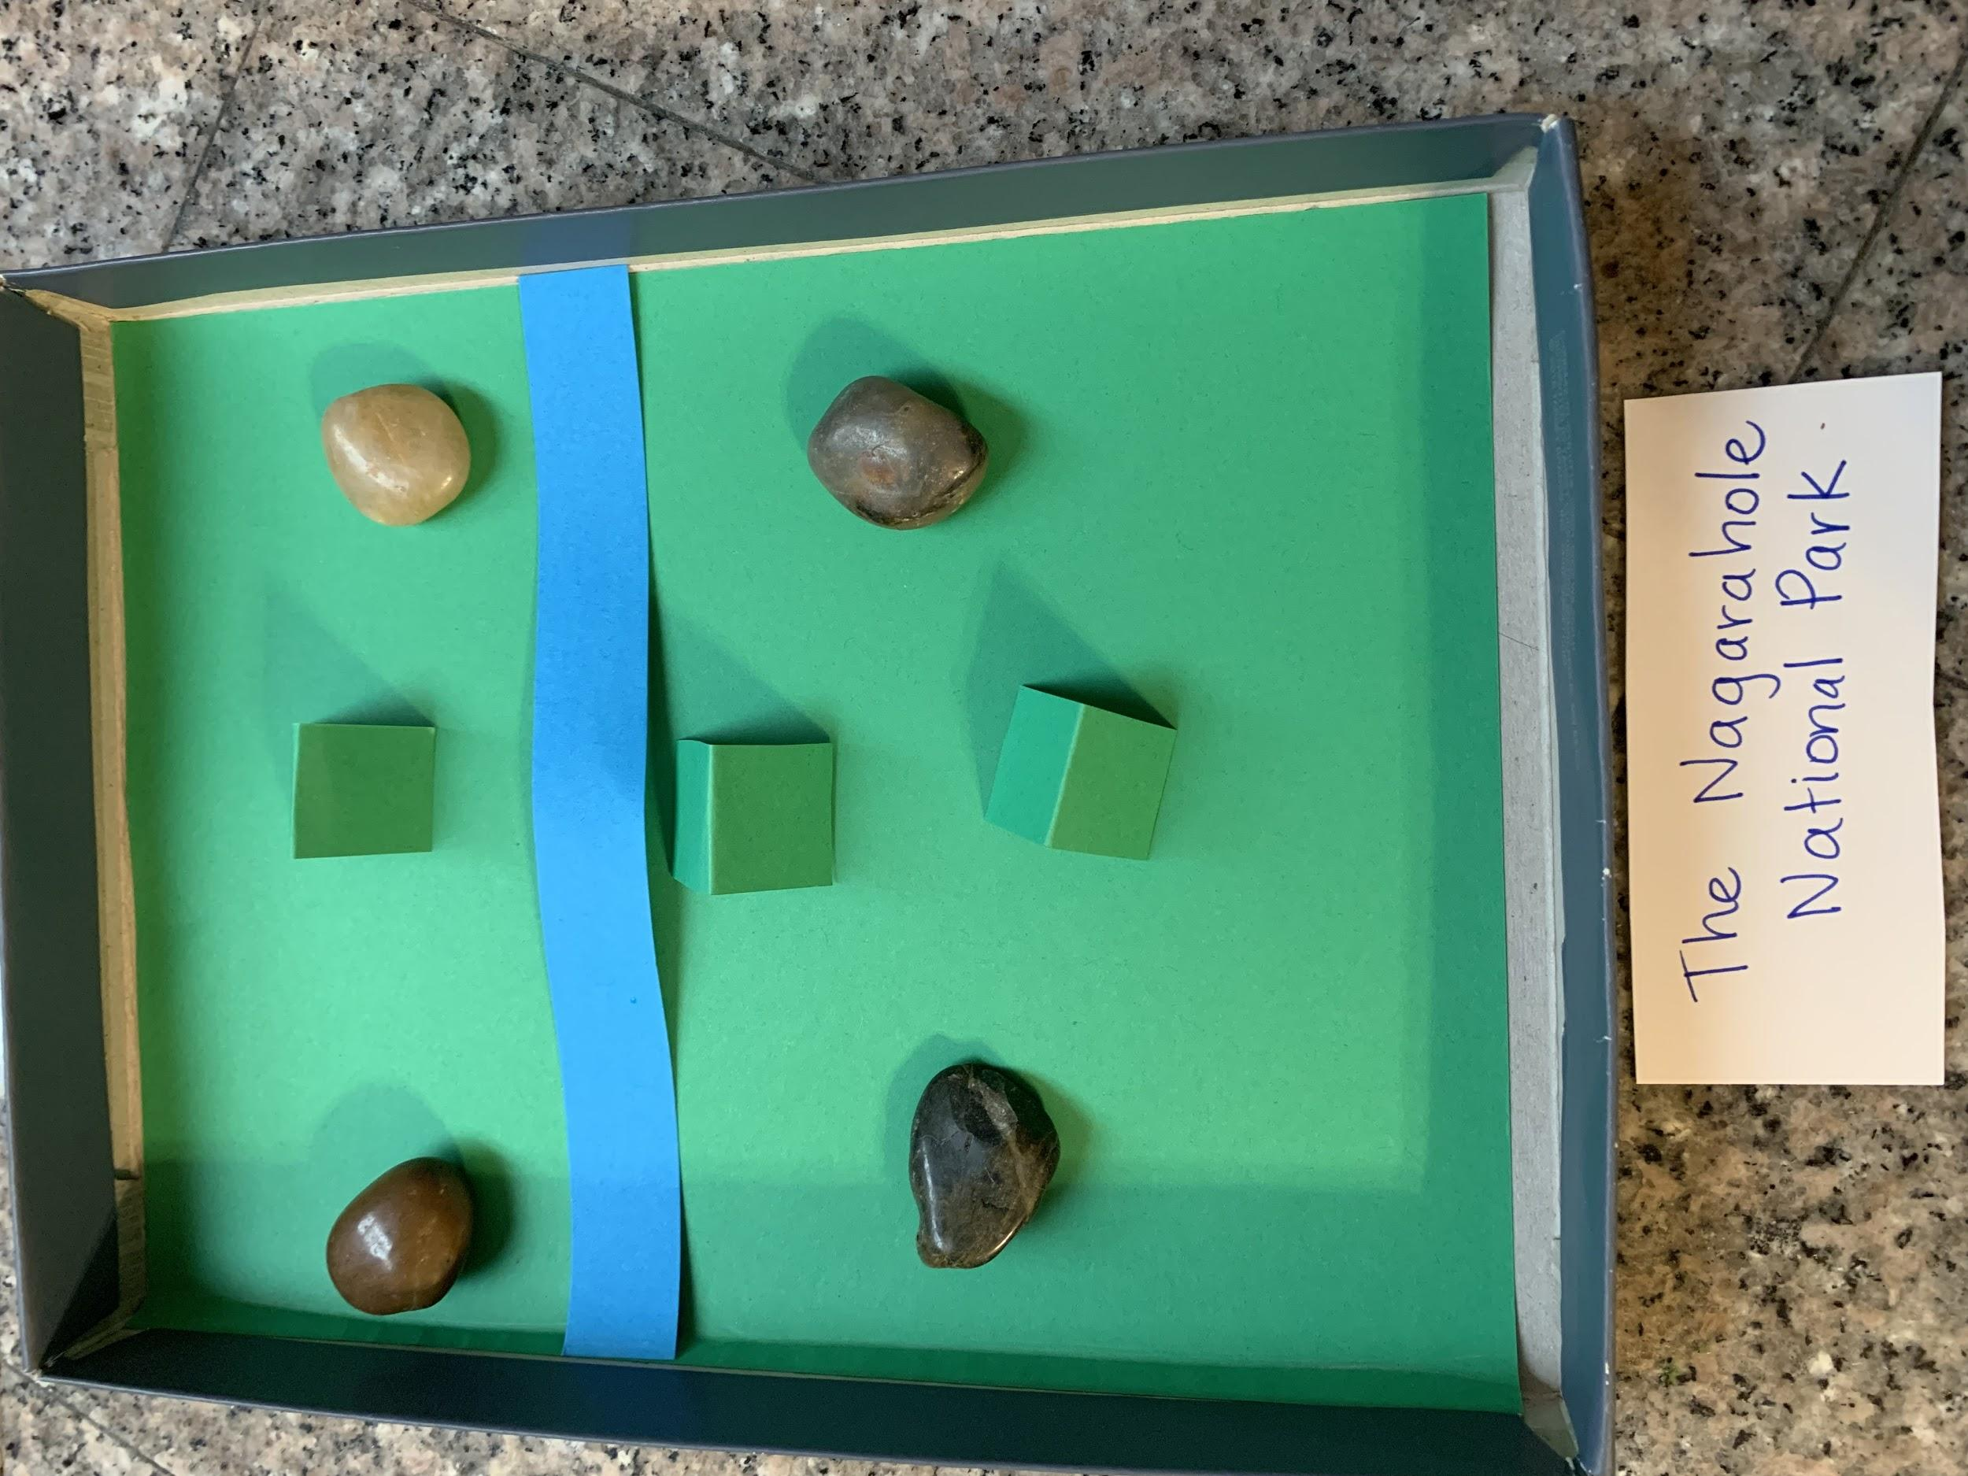
- To create the Nagarahole National Park (rainforest) - place green construction paper inside to cover the whole lid. Add 4 rocks (two on each side) and add trees. To make trees, cut (1x2 inch) green rectangles, and fold them in half to make a stand up tent), cut a sliver of blue construction paper for the river.

- To create the Andaman and Nicobar Islands (Indian Ocean) - place blue construction paper inside to cover the whole lid. Add 2 strips of tan paper (one on each side) and 2 rocks (one on each side). Add 4 trees (2 on each side).
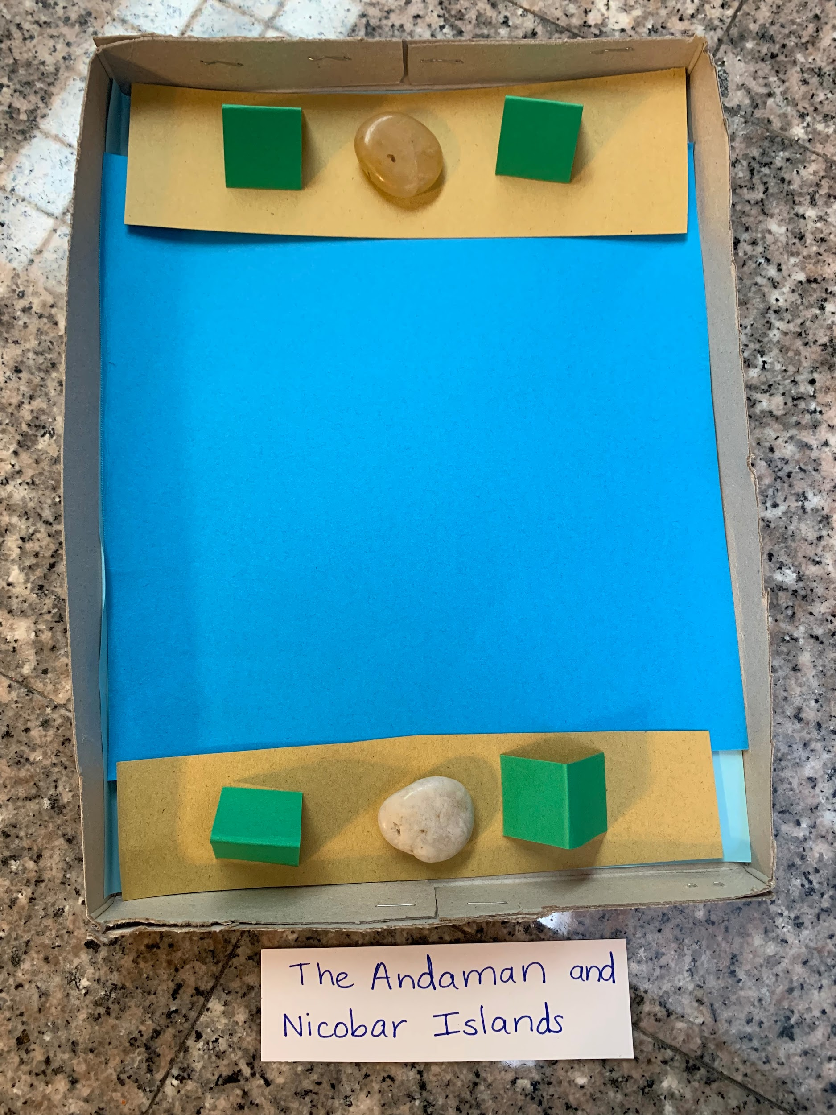
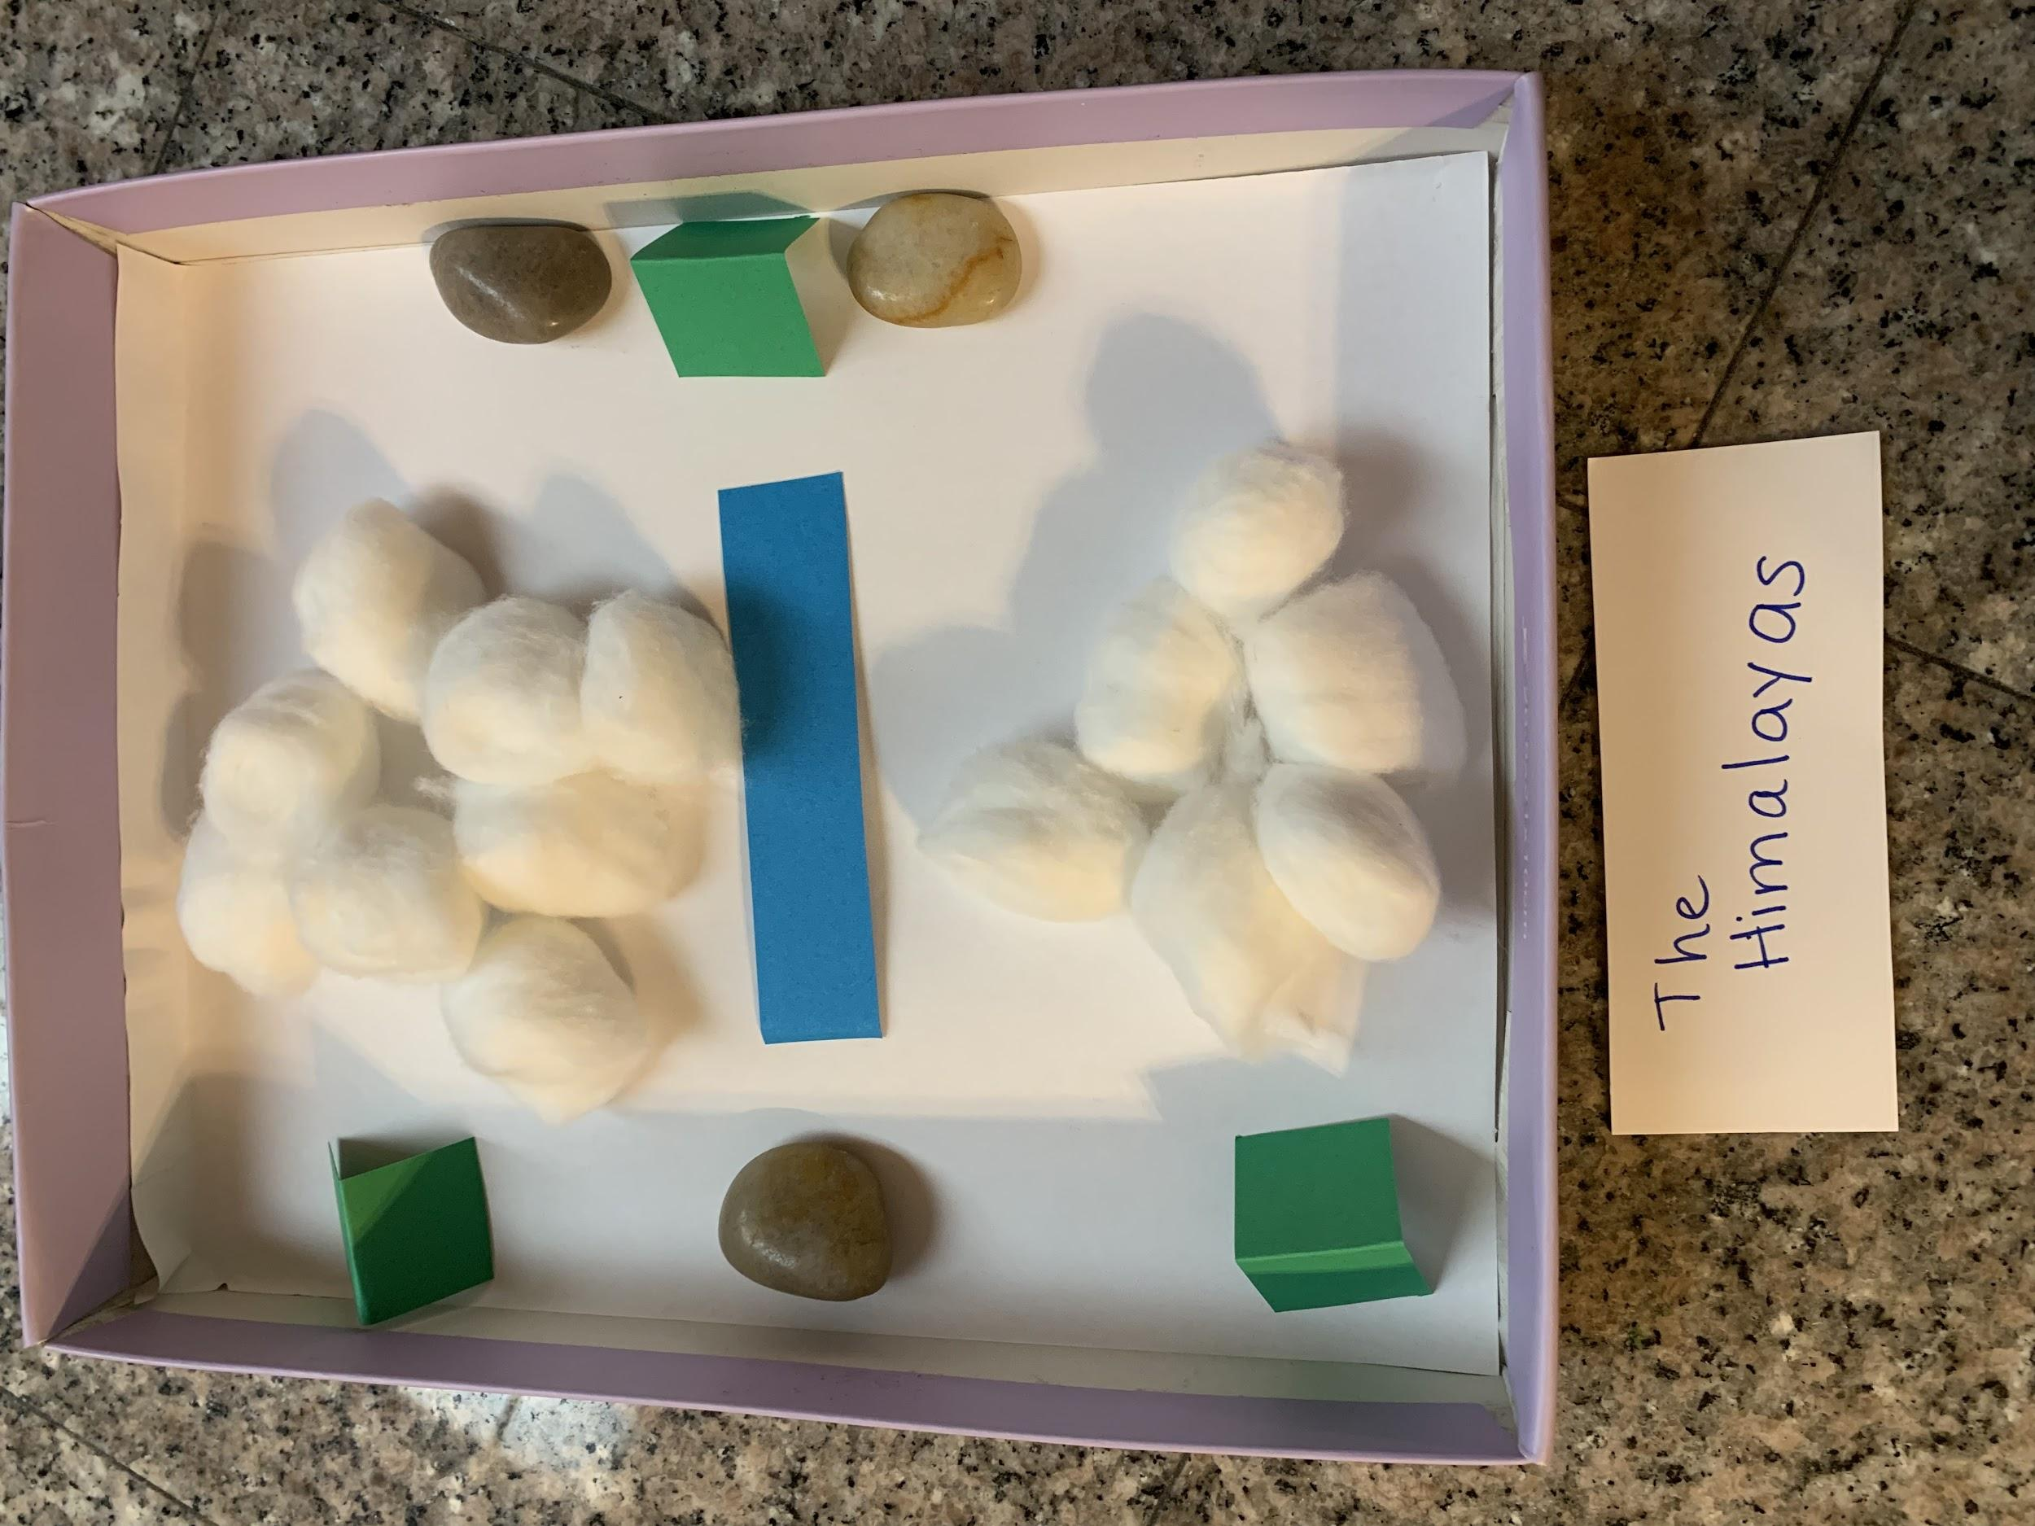
- To create the Himalayas (snowy forests) - place white paper inside to cover the whole lid. Place a strip of blue paper in the center for the river and a handful of cotton on both sides, for the snow. The remaining rocks will be placed on the opposite sides and 1-2 trees next to them.
d) Copy pictures on cardstock (3 sets), cut out each set and place into ziplock bags.
Students will work in groups of 6-7 students per ecosystem model (for 3 models).

Engage - (5 minutes)
Students will watch a short video clip from The Jungle Book.
https://youtu.be/OD3CLzPER34?list=LLVvVo6777lYoRGBL9vksdVw
Discussion after clip: Why did the tiger say, “Man is Forbidden” in the jungle? The teacher will discuss why most animals feel threatened by man. What is the relationship between the animals and man? Student responses may vary: man has cut down their trees to create villages/towns/cities, set fire to the forests, killed other animals, etc.
Explore/Explain - (15 minutes) group work
- Teacher will write on the board:
The Naragahole National Park
The Himalayas
The Andaman and Nicobar Islands
The teacher will explain that all 3 places are homes to animals in India and will have students read the names of the places aloud.
- The teacher will place one model (per group) on the table, and will have students observe what they see. Give students a minute to discuss.
Encourage students to identify the parts in their models:
a) green tents=trees/forest area, b) rocks=mountains, c) blue paper=water, d) green paper=grass, e) white paper=cold area, f) cotton=snow
- Give each group an index card and have them identify and write down what place they think they have, using the names of the places on the board, and landforms and bodies of water they see. The teacher will confirm student responses before they write them down. Each place can only be used once.
- Class Discussion: Review and discuss: what do animals need to survive? Have students predict what animals could live in that place and what type of ecosystem may be there (for example, I think a _______ can live here in the... Marine, Tropical Rainforest, Deciduous Forest, or Desert, etc.).
- Each group will have a set of picture cards (9 cards per set). Ask each group to choose only 3 pictures of animals that could live there. Groups will discuss and share why they chose those cards. The teacher will walk around and monitor conversations. Remind students that every group should have 3 different animals (no three will be the same), which means that they will not use 6 of the cards. Ask students to place the unused cards back into the bag, after they have chosen their three animals.
Elaborate: (15 minutes)
- Class will take a quick gallery walk and discuss why those animals would thrive and why the others would perish.
- Groups will go back to the table and the teacher will pass out Fact about their ecosystem.
- Students will read about their place/ecosystem and will check to see if they chose the correct animals according to habitat.
- Students will fill out Part 1 of their response sheet together (each student receives their own copy). Students will discuss and record answers to the following questions: Name of place. What 3 animals live there? What do these animals have that allow them to survive in this environment? What is the ecosystem like?

Evaluate: (20 minutes) whole class
- Students will watch a video clip from the Naragahole - Tales from an Indian Jungle. (watch from the beginning and stop at 7:00 minutes)
https://youtu.be/qsyhzZidZOQ

- Students will complete Part 2 of their response sheet (answers based on video).
What were 3 harmful changes in the video?
What were 3 helpful changes in the video?
If a new city was built on land that used to be a forest, what sort of changes to the environment do you predict might happen?
End the lesson with a discussion of how the animals in India have had to endure many changes with their environment, especially with villages built, roads, and highways made, and even poachers who have killed off certain species. Encourage students to think like a Wild Conservationist and to be able to report their findings of wildlife in India.

Extension
Encourage students to research ideas of how they can help the animals in their community to thrive. This is a link of how students can help animals in shelters. https://www.petakids.com/save-animals/help-shelter-animals/

