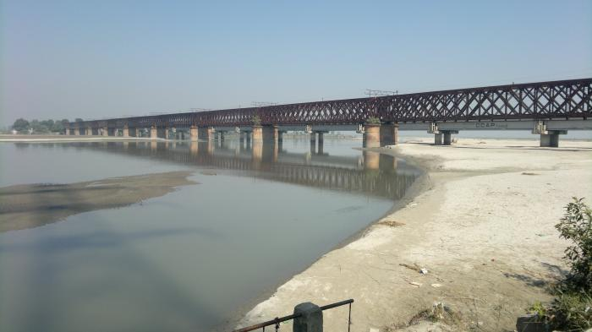
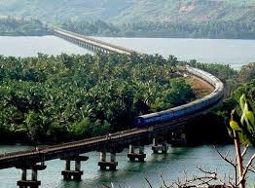
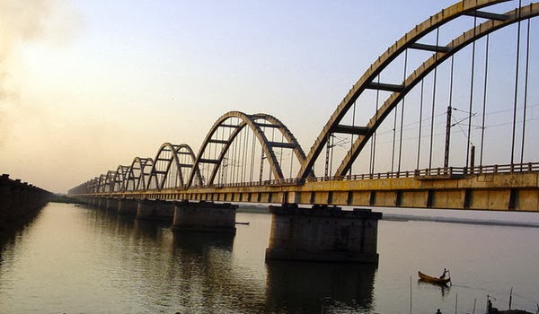
Overview & Purpose
Students have just left the rural areas of India, and are ready to say goodbye to the wildlife on the reserves. Students are now ready to come back into the inner cities of India. As they get ready to cross back over, they notice a huge bridge linking the forests to the city. They are amazed by its strength and begin to wonder how it works. They decide to explore how engineering has impacted the development of bridges over time, including innovative designs and the challenge of creating bridges that become landmarks for cities. In this lesson, students will learn about bridge design and use their knowledge of forces to engineer a strong bridge made of paper. They will discover the beauty in India’s Top Ten Longest Railroad Bridges.

Education Standards
(3.2) Scientific investigation and reasoning
The student is expected to:
(A) plan and implement descriptive investigations including asking and answering questions, making inferences, and selecting and using equipment or technology needed, to solve a specific problem in the natural world;
(B) collect data by observing and measuring using the metric system and recognize differences between observed and measured data

(3.6) Force, motion and energy
The student is expected to:
(C) Observe forces such as magnetism and gravity action on objects

Materials Needed
Each pair of group of students needs:
- ruler
- Scissors
- several sheets of typing paper
- two stacks of books
- pennies (recommend having at least 400 pennies on hand - some bridges are VERY strong)
- Bridge Challenge Handout (one per team)
- Civil Engineer Notebook Handout
- Teacher Tips handouts (suggestions for guiding students in building a bridge)

Vocabulary
Observation
Cooperation

Student Objectives
- Students will learn about the ten longest bridges in India.
- Students will learn about civil engineering & design process.
- Students will learn about teamwork and working in groups.

Activity
- Engage - Chalk Talk activity (http://bit.ly/ChalkTalkLink): The Chalk Talk thinking routine provides an opportunity for everyone to be given a chance to be heard. Thinking becomes visible and it encourages students to consider others' viewpoints.
Prepare two pieces of butcher paper with the following question in the center of each paper: How do bridges connect worlds together? Divide the class into two teams. Each team will gather around the butcher paper. Each team member will need a marker to write.
  - Tell your students to write down any ideas that come to mind when they consider this idea, question, or problem.
  - Ask your students if they can make any connections to others' responses. Have them add these connections to the chart.
  - Then have the students add to the chart any questions that come up as they think about the ideas and consider their classmates’ responses and comments.
  - After 5 minutes, have students from each team select a spokesperson. The spokesperson from each team will share some of the highlights that their team wrote.
- Explore:
  - Show the following video: https://www.youtube.com/watch?v=FQOhPLJSVAU
  - Tell students to think about the following questions as they watch the videos:
    - How much time and effort went into constructing the bridges?
    - What are some similarities and differences between the bridges?
  - Show the PowerPoint titled “Connecting Worlds Together” to the students. Ask if they recognize any of the bridges from the videos they watched.
- Apply:
  - This engineering design activity helps students develop the ability to solve problems creatively and systematically.
  - Read over the Teacher Tips handout to guide students in the engineering process.
  - Give each student pair/team the Bridge Challenge and Civil Engineering Notebook Handouts. Discuss the building activity with students.
  - Allow plenty of time for students to fail (failing is good), redesign, and collaborate as a team.
- Investigate:
  - After constructing their bridges, students will test their bridges using pennies, evaluate their results, and present their findings to the class.
- Reflect:
  - Reflect on the design process, use of materials, and team synergy to construct their bridge.

Extension
Challenge advanced students to design and build a bridge out of popsicle sticks and glue that can hold a specific amount of weight (teacher discretion).

